EXPERIMENT 7

**AIM:** To realize the use and importance of statistical graphics in GUI.

**THEORY:**

The Problem statement given said that Matt is a young engineer who has just started working on his first job. His parents want him to handle his finances himself. He is looking for a tool/ app/ software that can help him budget his finances, create goals, track his expenses, categorize his credit card spending etc. He would also need help and motivation to start saving.

In order to solve the problem the effective solution is KEEPER. KEEPER motivates the user by giving daily quotes on saving and enables that the user is motivated towards saving. The website is customized based on person to person due to the login. The first screen after login is the dashboard that gives a total overview starting with the current month vs previous month expenditure, below that belongs the current goals to be achieved and hovering over it gives you an idea whether you can achieve that goal or not. It also gives the various offers related to the choices of the user. After that in a tabular form the current month spending for past few days is shown. The Spending Details gives the visual representation of the spending and the grouping of the expenditure into categories. Expenditure enables for adding an expenditure and also the tabular view of the amount spent. Lastly the goal tabs give the current goals and also shows the goal already achieved by the user and enables adding a new goal.

**IMPLEMENTATION**:

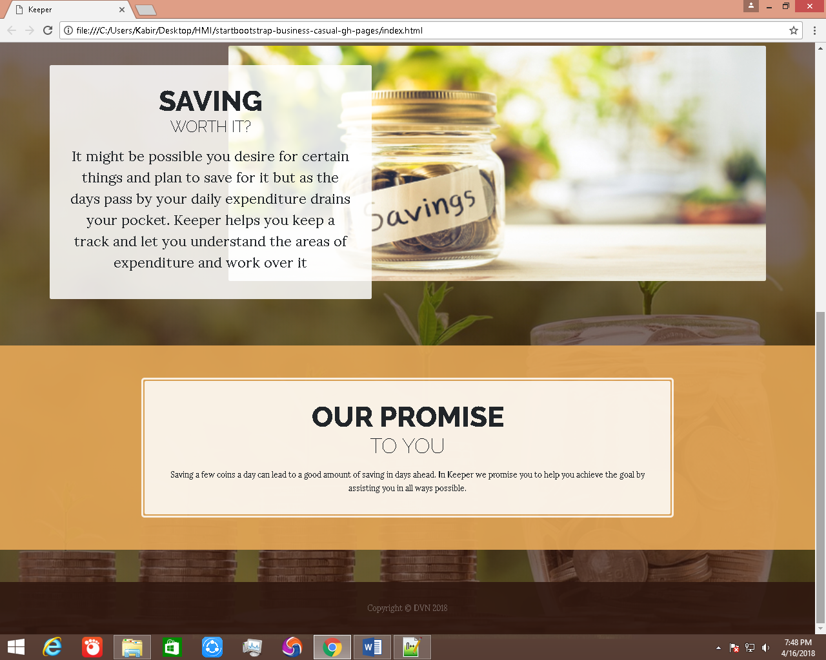

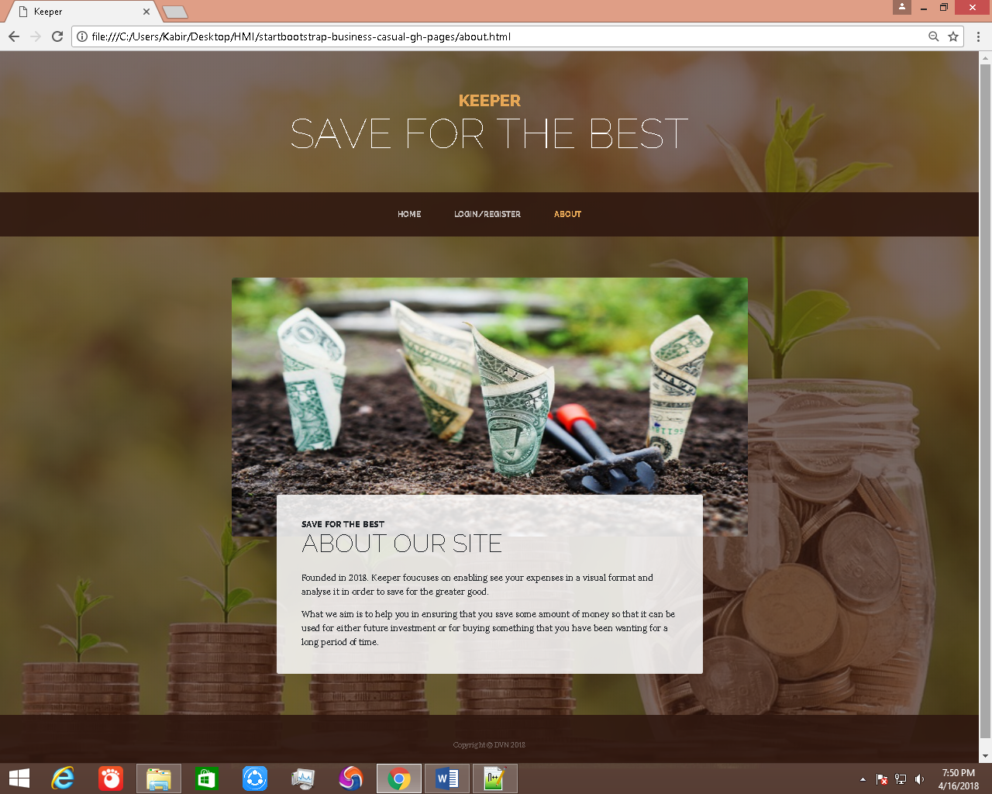

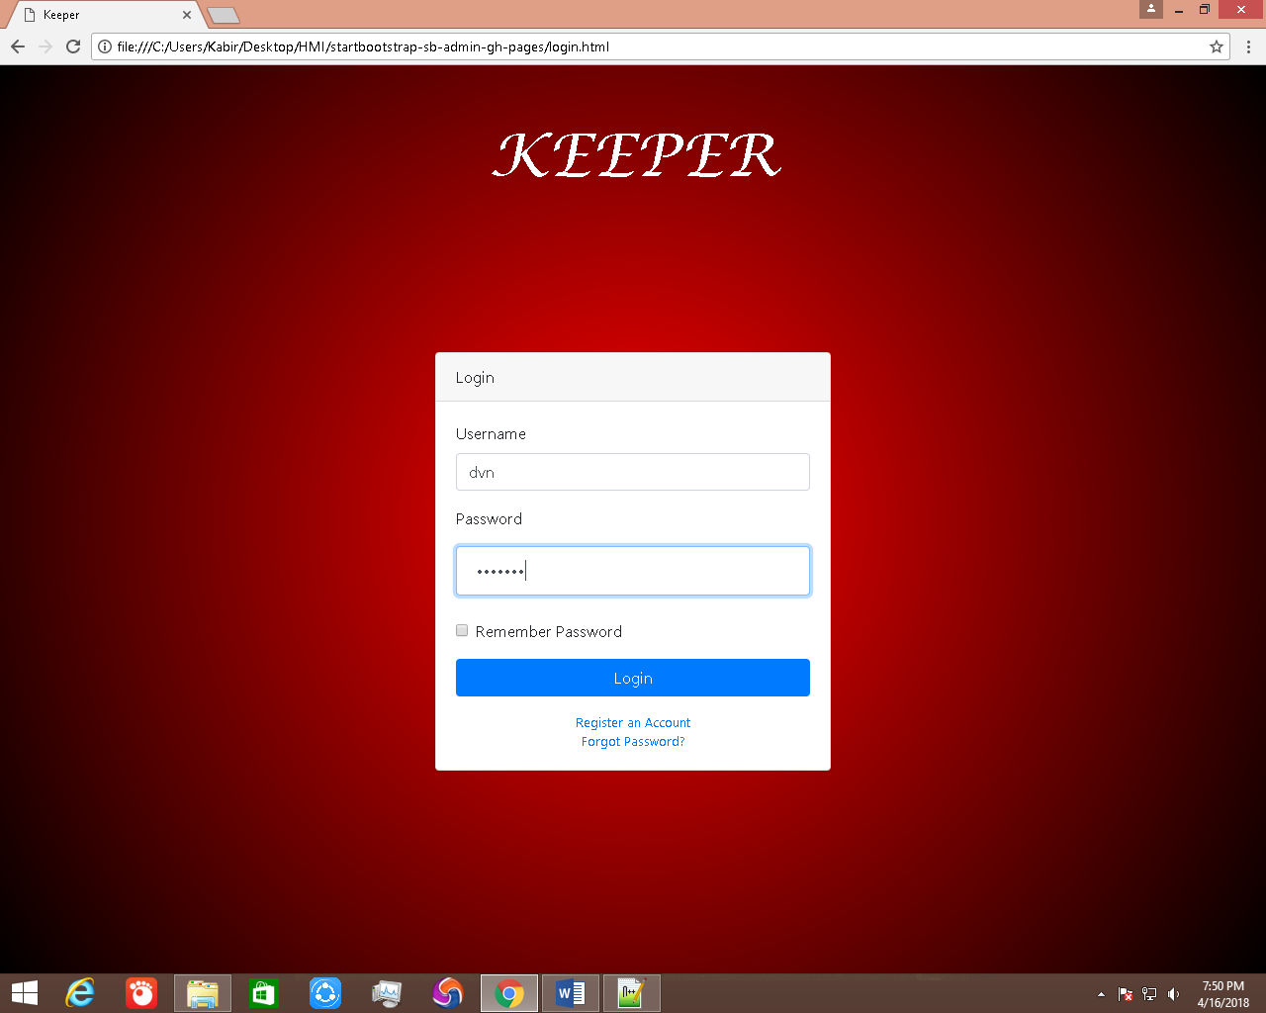

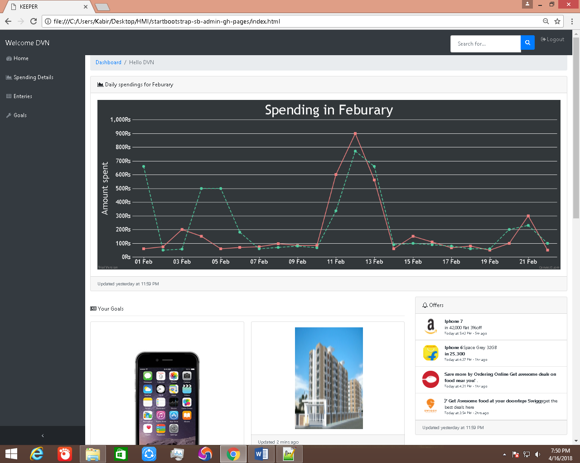

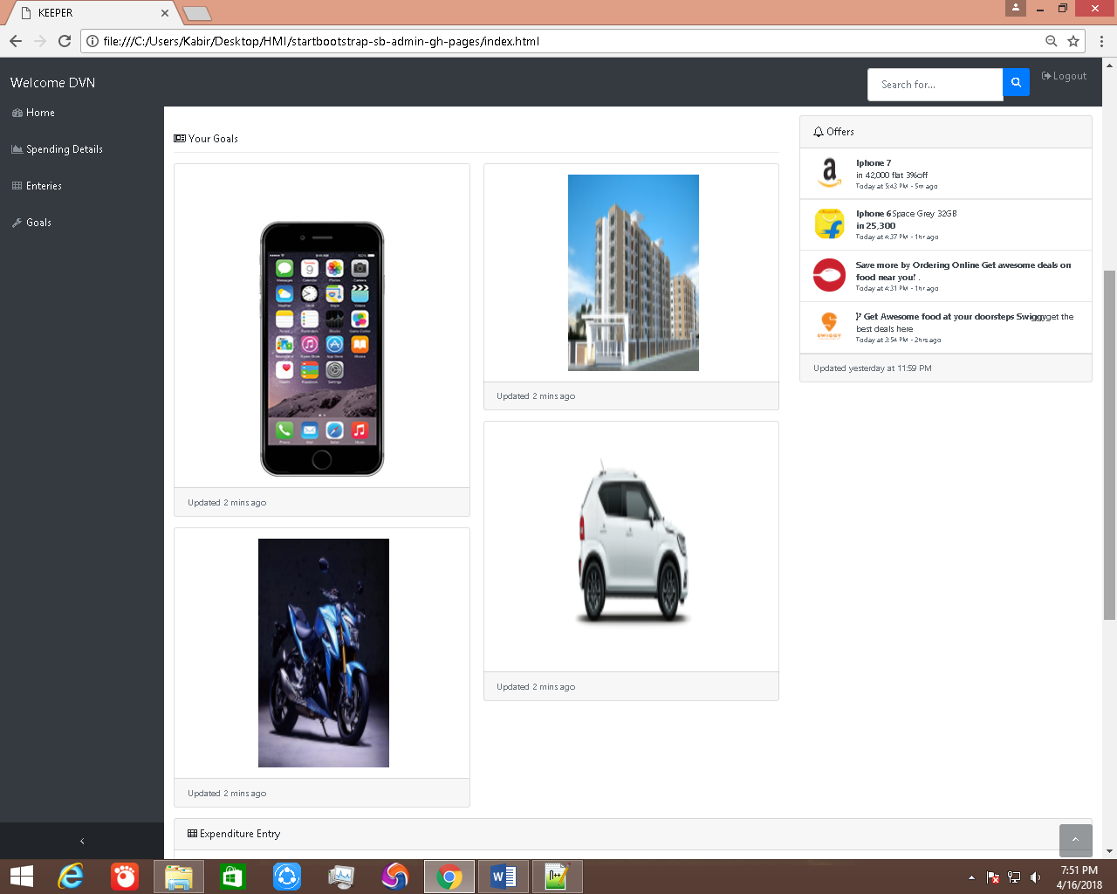

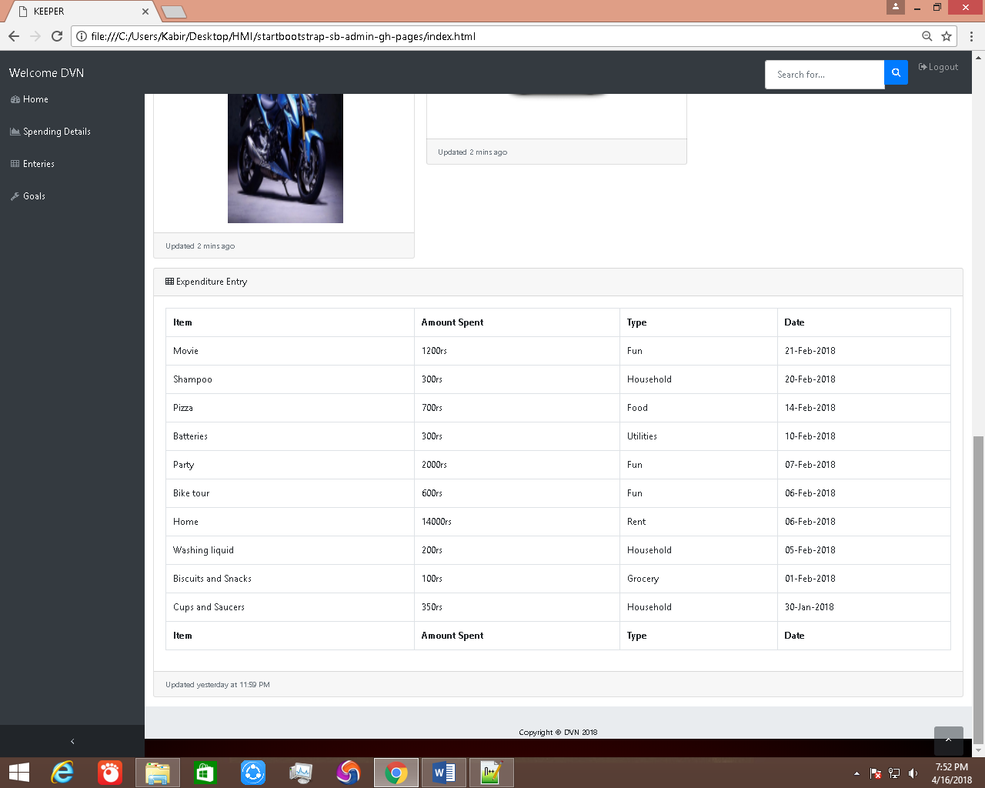

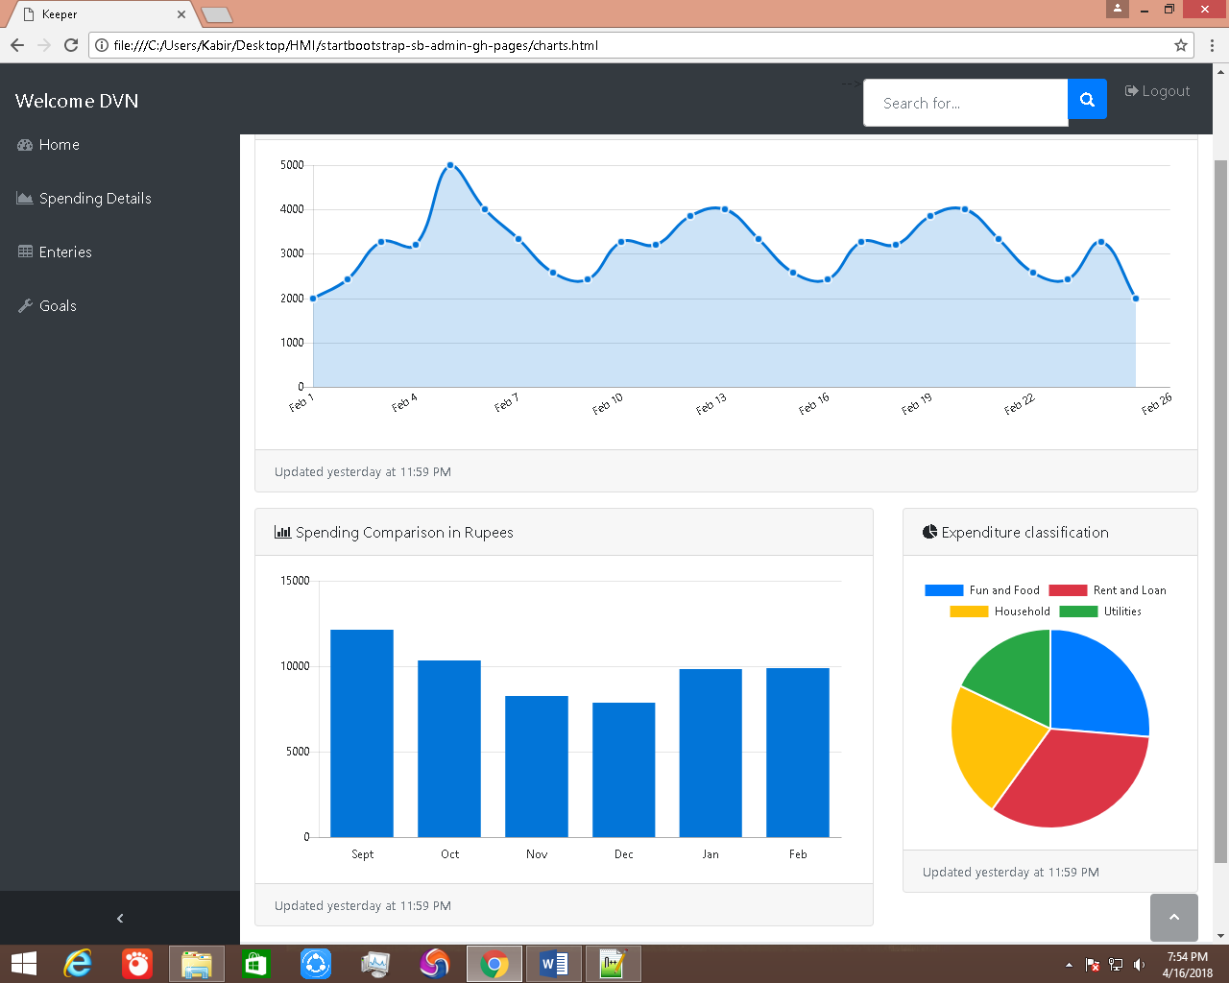

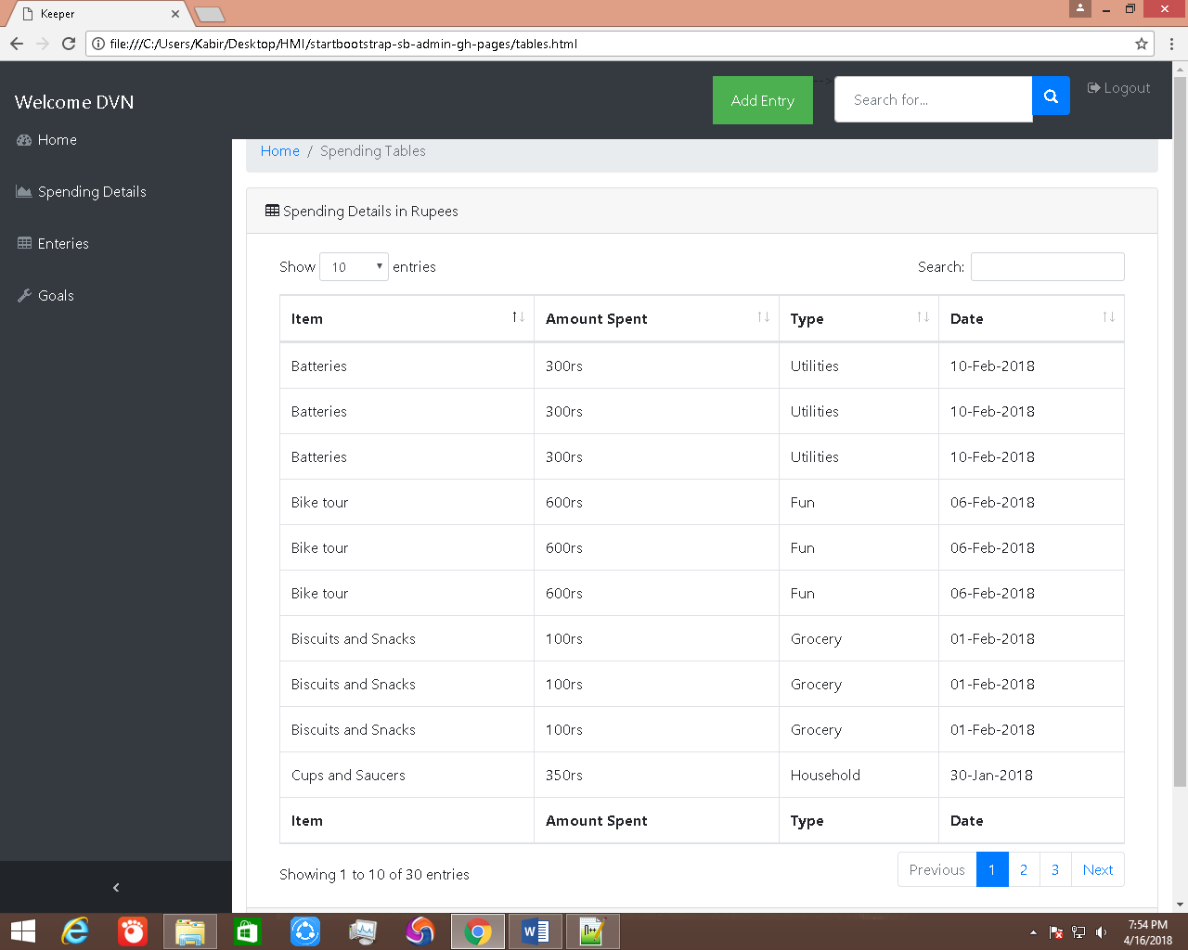

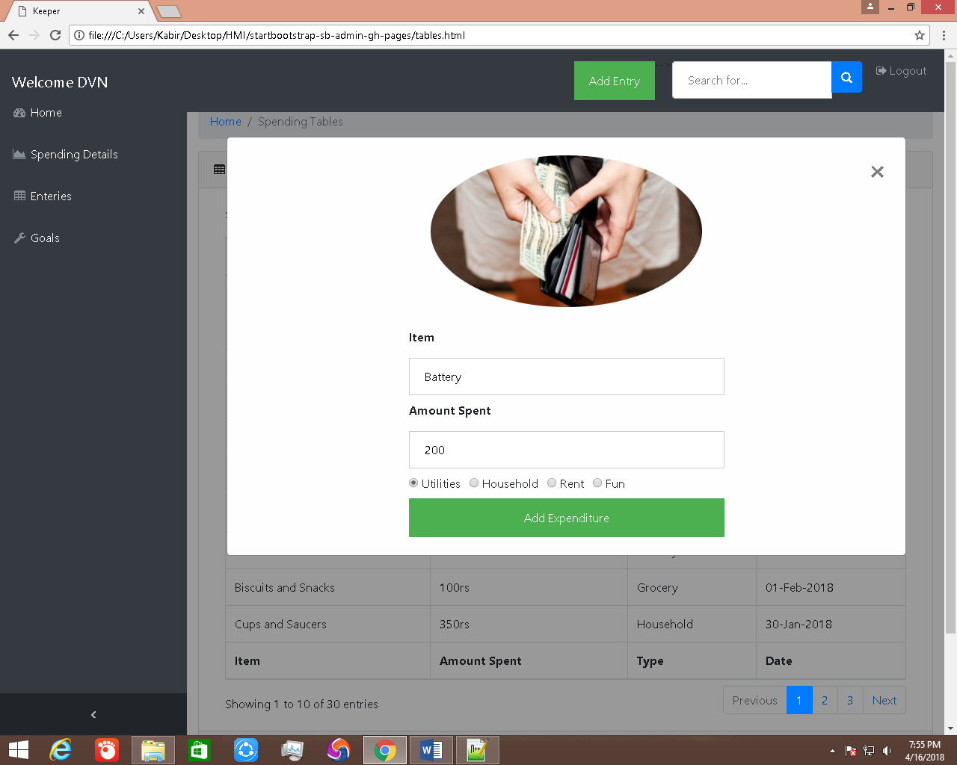

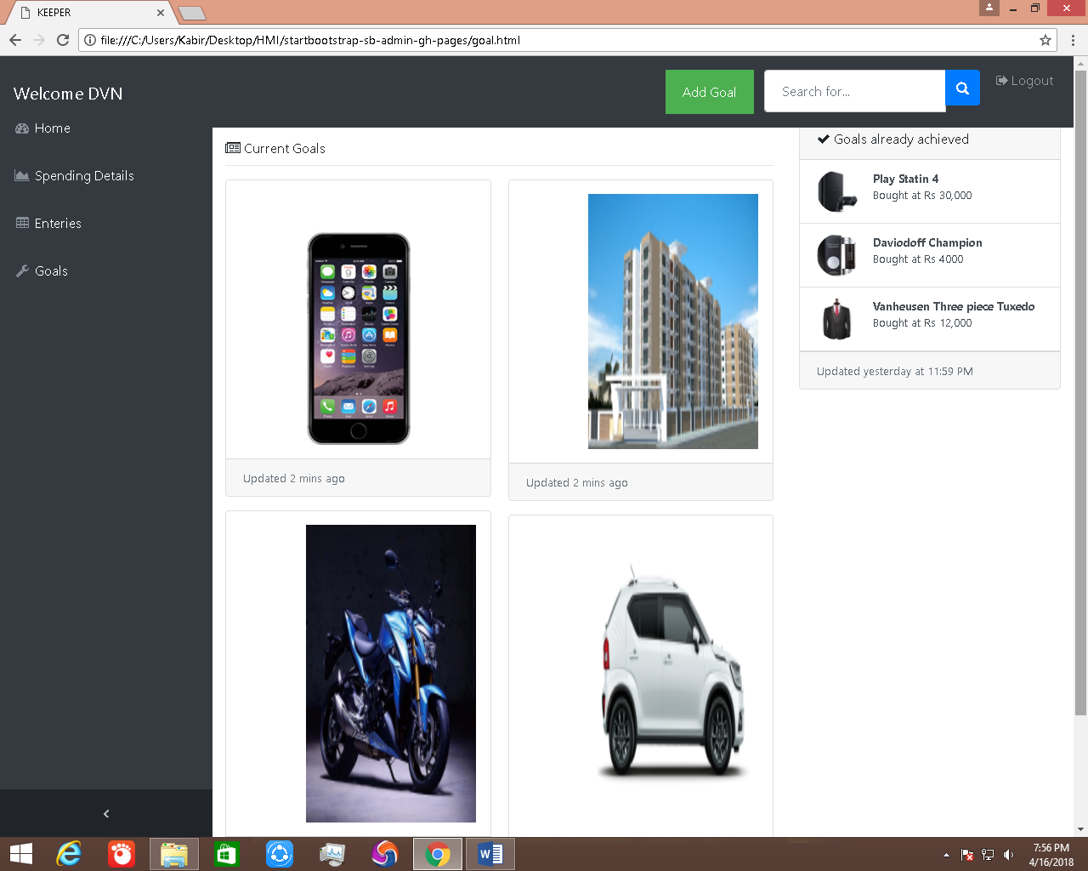

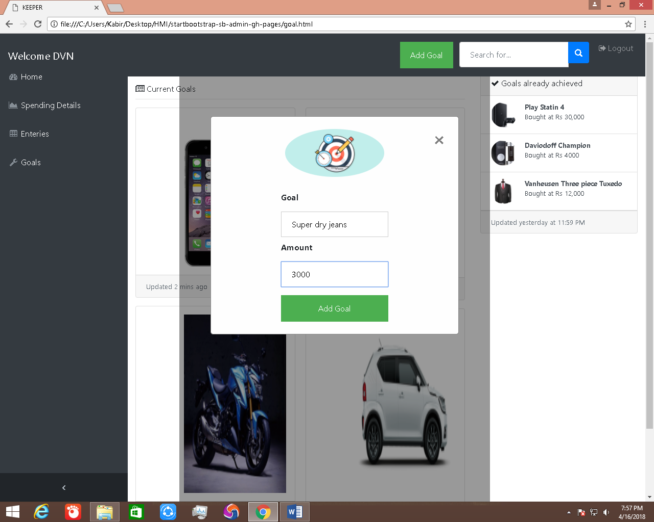

**CONCLUSION**: Considering the HMI principles in terms of aesthetically pleasing we have incorporated a design that is eye catchy and compatible to different browsers across different platforms. Comprehensibility is achieved by using images making the delivery of information easy and exact. Efficiency is achieved as the data is provided as per the query and the suggestion are also provided in quick and easy manner. Forgiveness is achieved by providing tooltip information in the form of alert .Responsiveness for every click an appropriate feedback is provided. We have explored the effects of animated transitions on graphical perception of changes between related data graphics.